**DEPARTMENT OF ELECTRONIC AND TELECOMMUNICATION ENGINEERING**

**UNIVERSITY OF MORATUWA**



**EN3160 - Image Processing and Machine Vision**

Assignment 01

Intensity Transformations and Neighborhood Filtering

**PUSHPAKUMARA H.M.R.M.**

**200488E**

September 01, 2023

**Question 1**

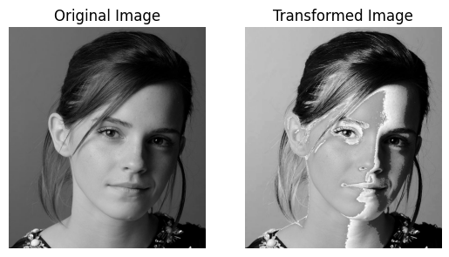

The transformation has enhanced the input intensities between 50 and 150, making input intensities near 150 appear white in the output image.

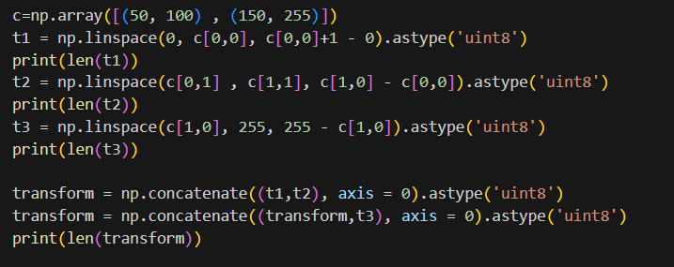

**Question 2**

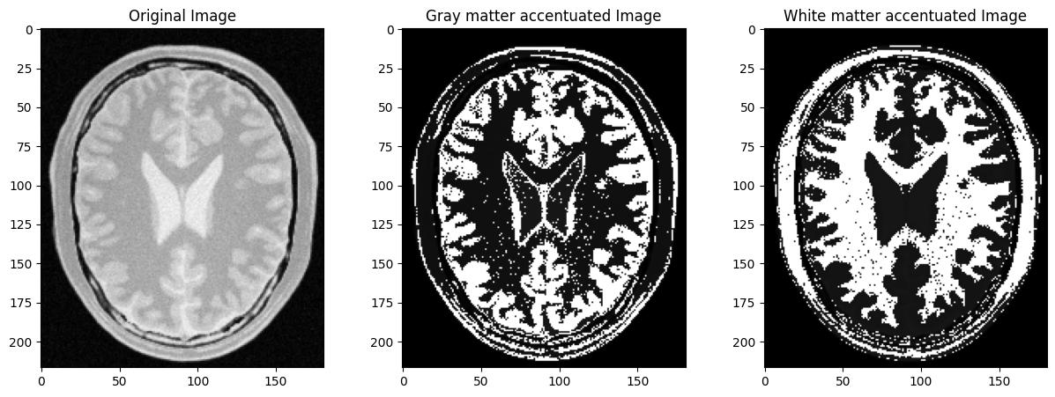

The transformations I have used to enhance white matter and gray matter are as follows.

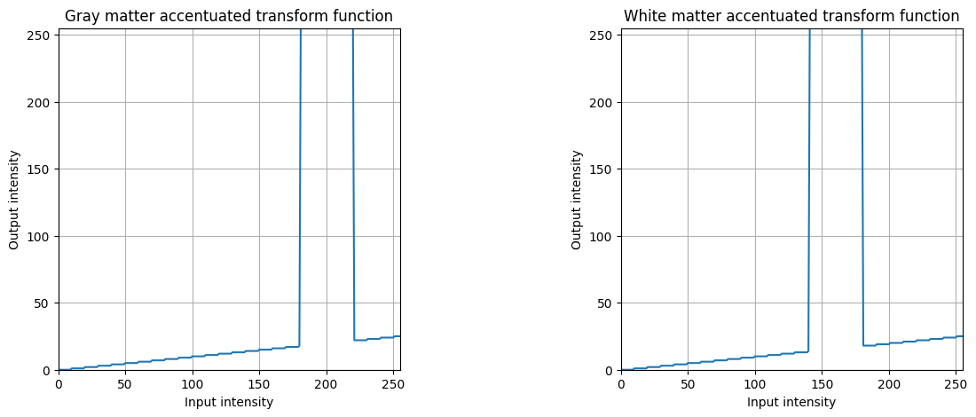

I found that the pixel intensities of the gray matter are between 180 and 220 in the input image and pixel intensities of the white matter in between 140 and 180 in the input image. Therefore, to enhance gray matter I increase pixel intensities between 180 – 220 to 255, and other intensities are lower by a factor of 10. To enhance white matter, I did the same for 140 – 180 input intensities.

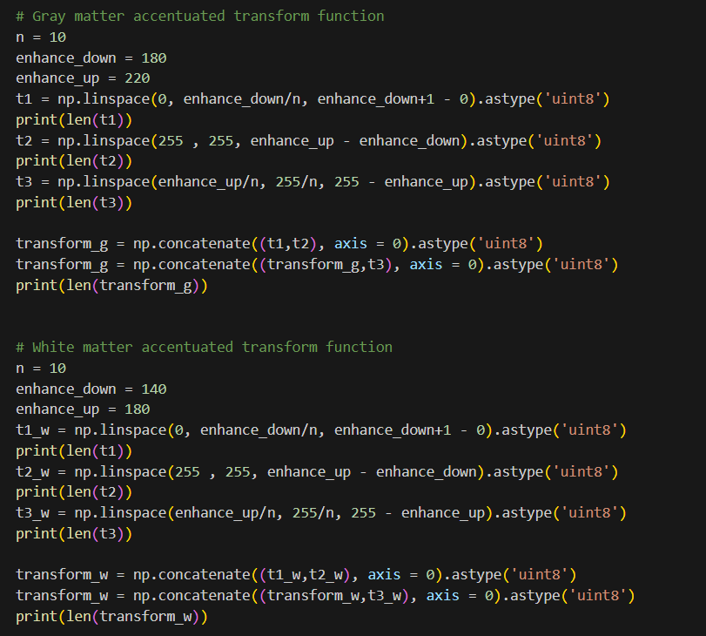

**Question 3**

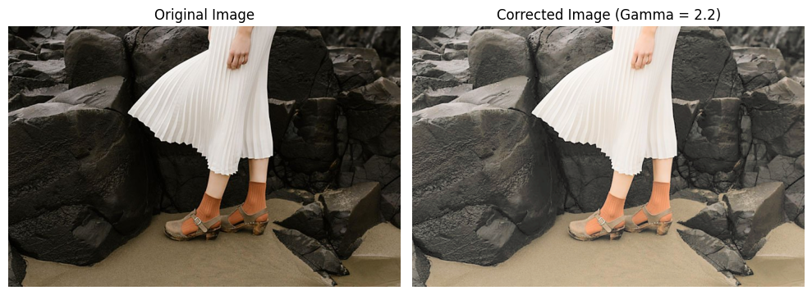

Here the Gamma value that I used is 2.2.

The histograms of the image before and after the gamma correction are,

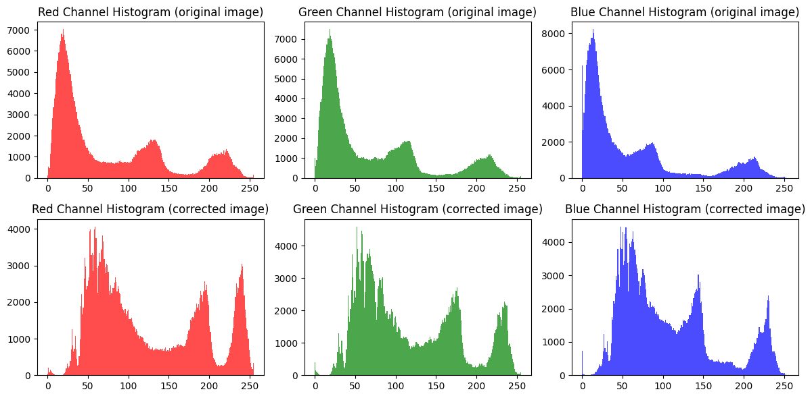

Here we can see the brightness of the image has increased and dark areas have enhanced.

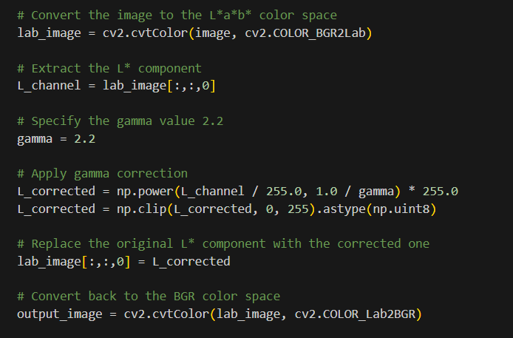

**Question 4**

1. Original image with hue, saturation, and value planes.

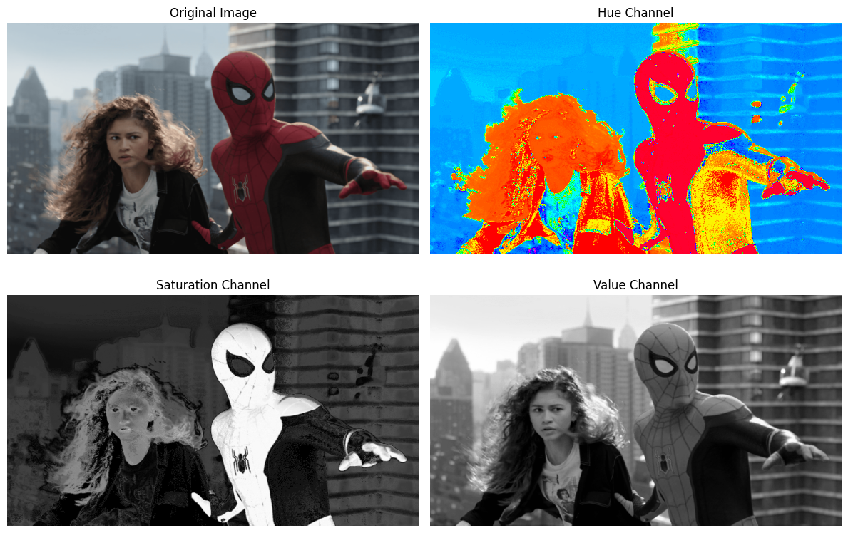

1. After applying the given transformation to the saturation plane for the different values of **a** between 0 and 1.

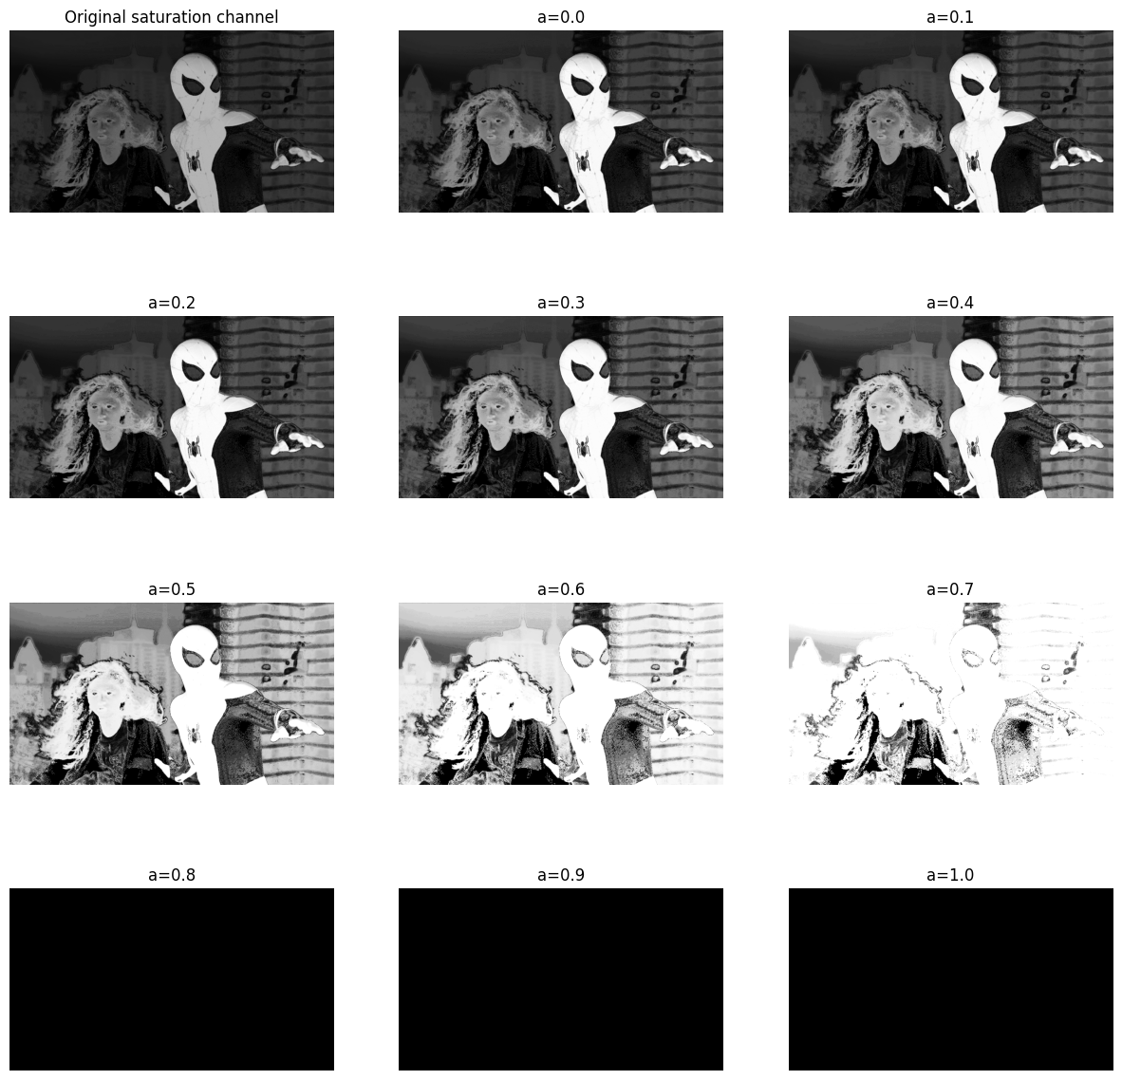

1. By the above observation, I choose **a = 0.4**. Here the original saturation channel and transformed saturation channel with a = 0.4.

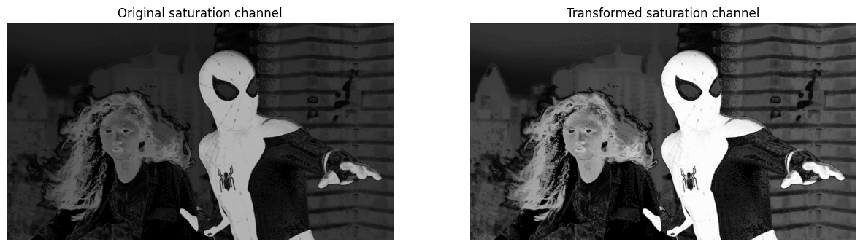

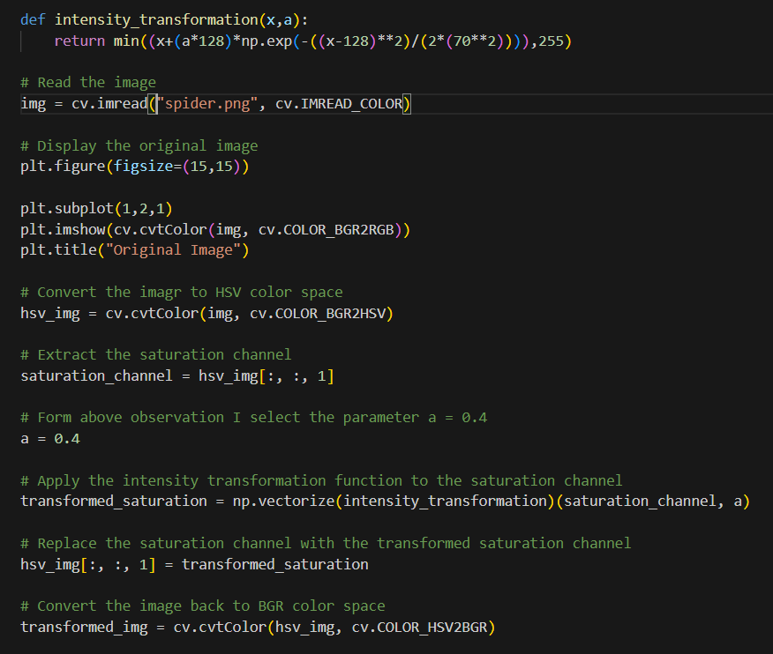

1. After all, the original image and the vibrance-enhanced image are as follows.

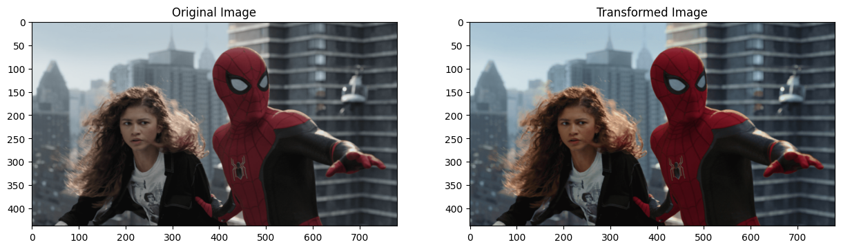

The intensity transformation is,

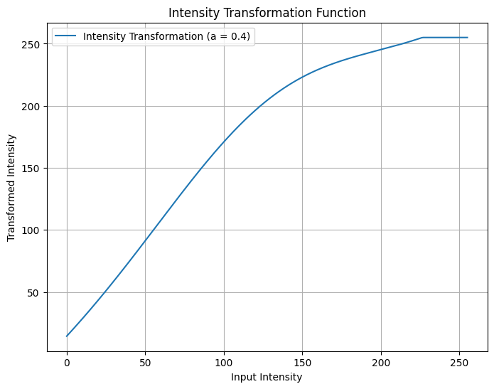

When we compare the input image and the output image, we can see the colors are more pleasantly visible in the output image than in the input image.

**Question 5**

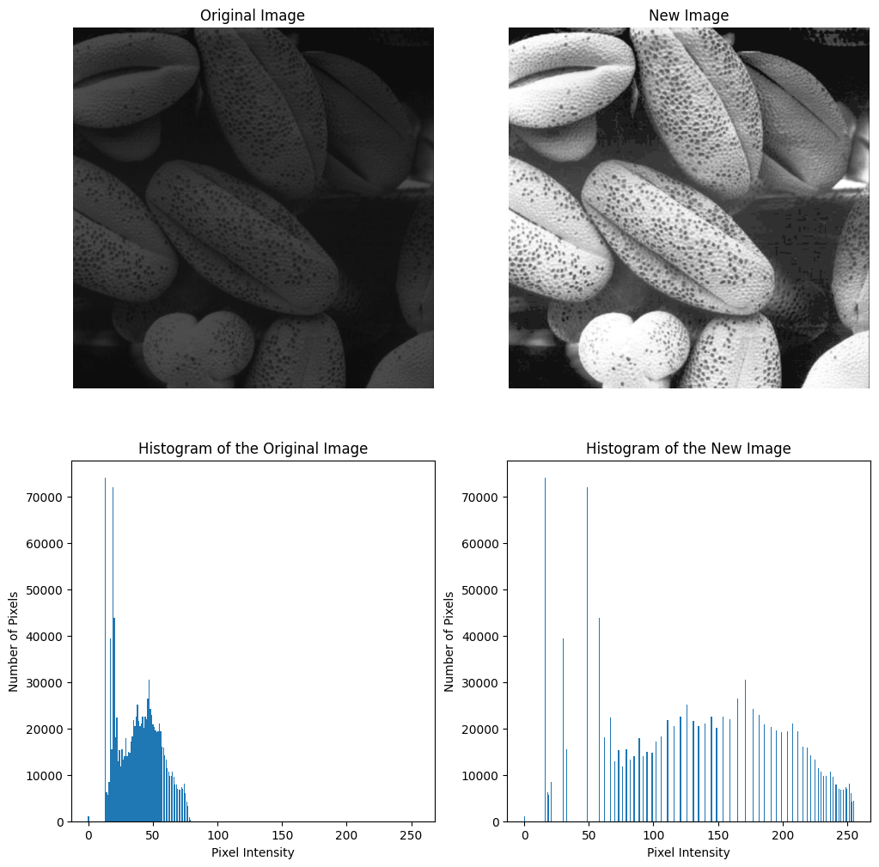

When compared with the original image histogram, the transformed image histogram has a more spread-out histogram (of course this is because of the histogram equalization) in high intensities. Therefore, the transformed image is lighter than the original image and we can see all features more clearly in the transformed image.

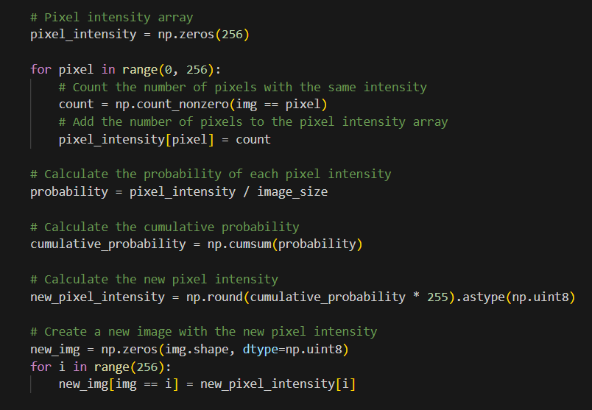

**Question 6**

1. Original image and hue, saturation, and value planes in grayscale.

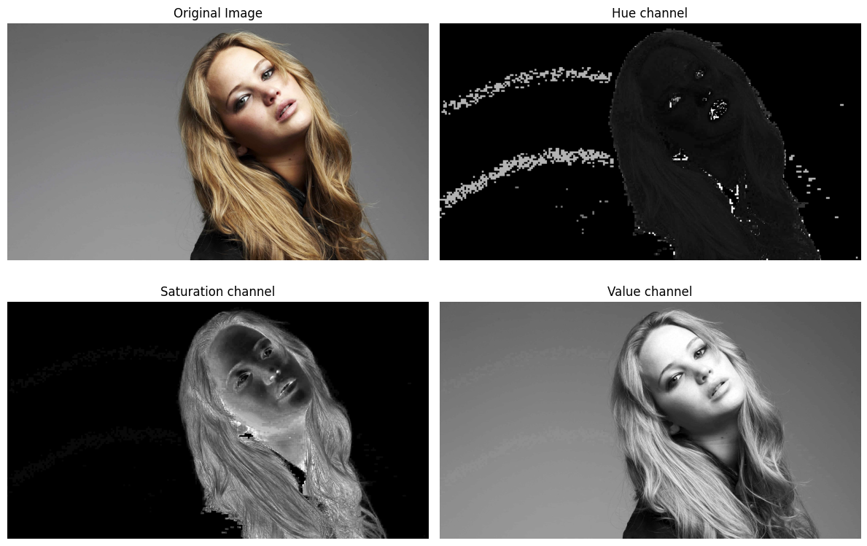

1. When we observe the above planes, we can see that the saturation channel has a clear difference between background and foreground. Therefore, I selected the **saturation** channel to extract the foreground mask.

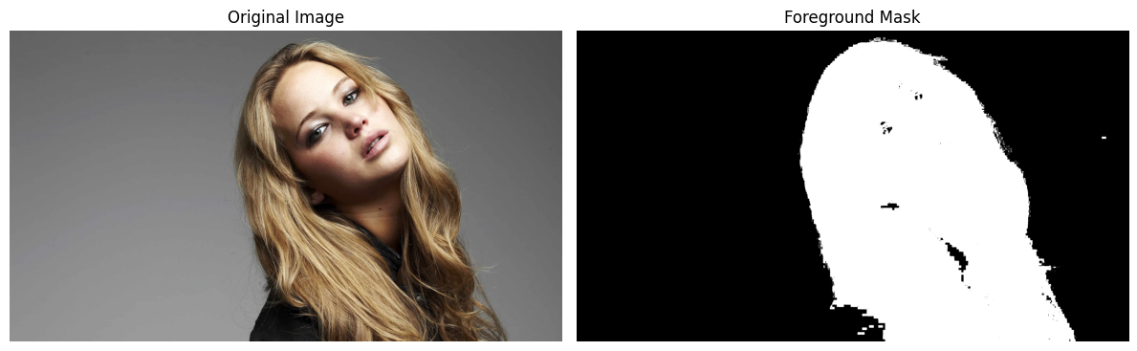

To obtain the foreground mask, I used 11 as the threshold value.

1. Obtained foreground by using **cv.bitwise_and** is,

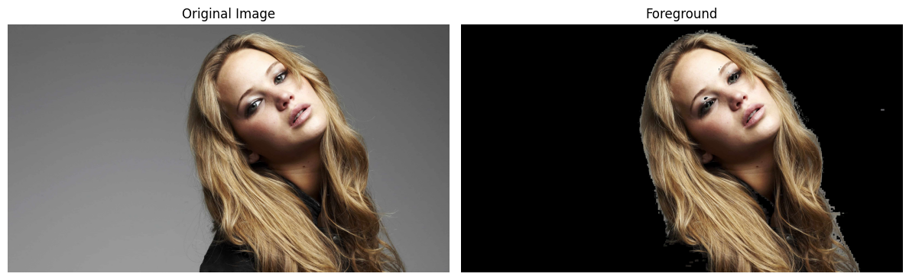

The histogram for the 3 channels of the foreground is,

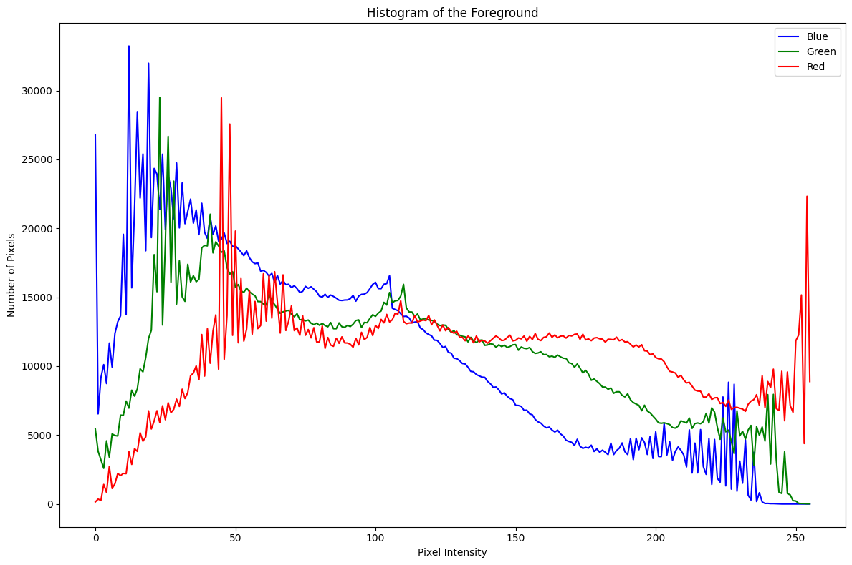

1. Cumulative sum of the histogram

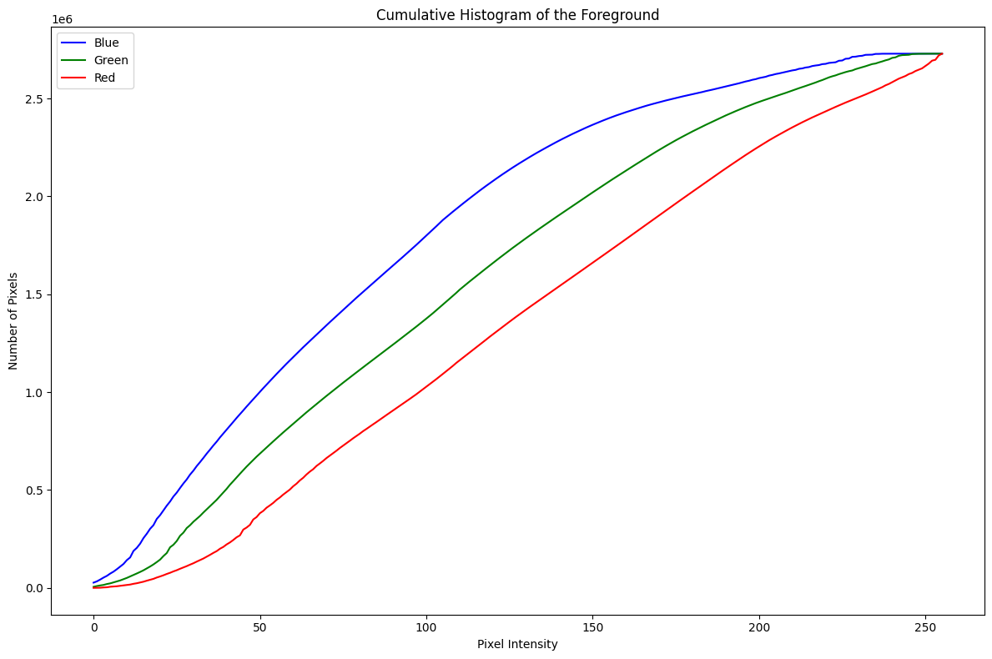

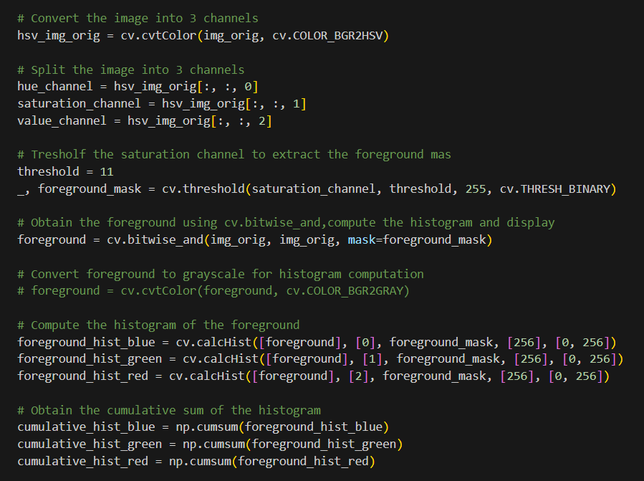

1. Histogram-equalized foreground

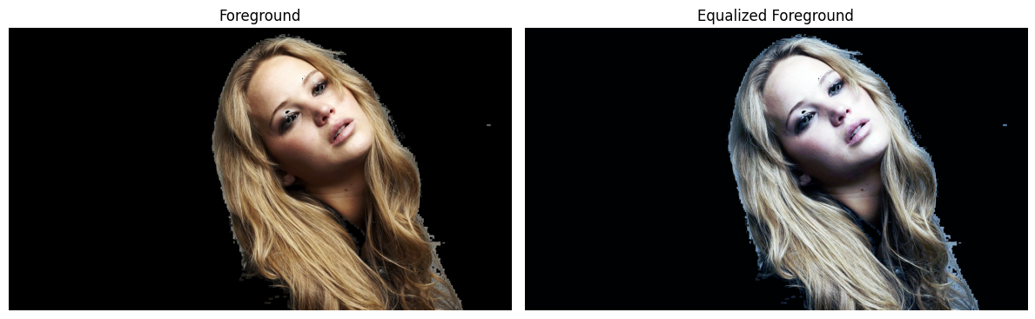

After the histogram equalization, the histogram and the cumulative sum of the histogram are as follows.

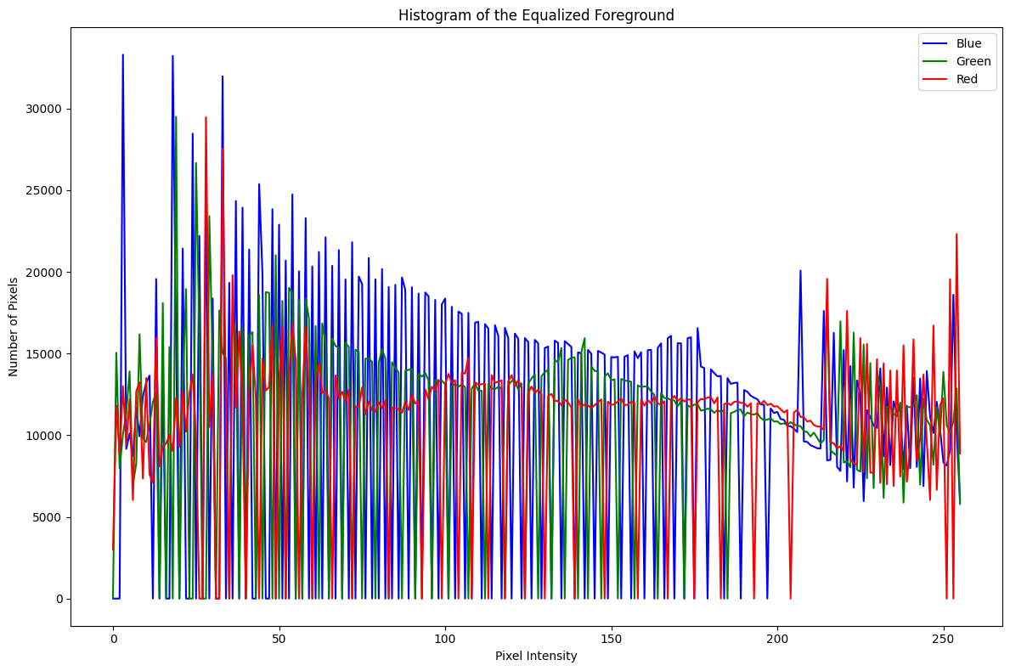

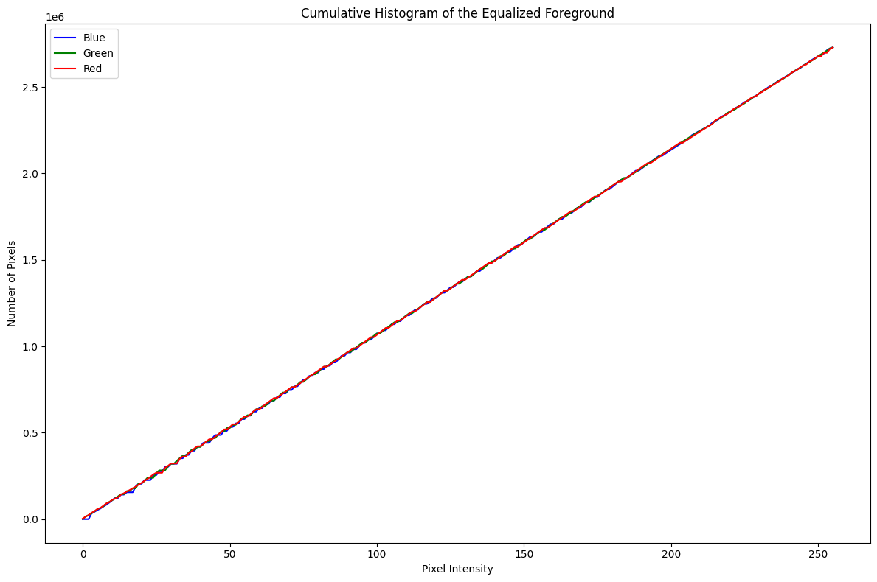

1. Extracted background.

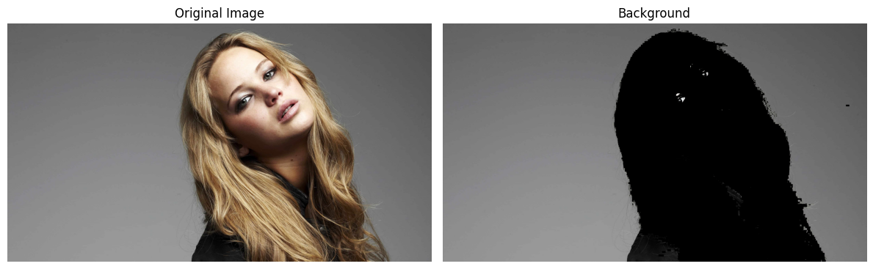

The result after adding the histogram equalized foreground with the extracted background is,

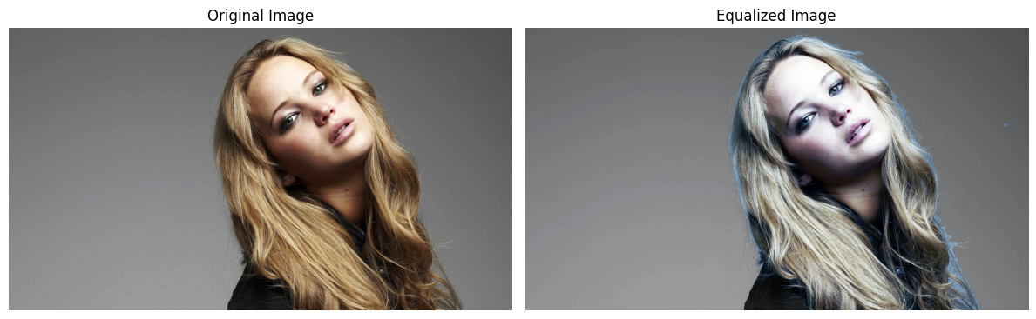

This is the equalized image and the original image in grayscale.

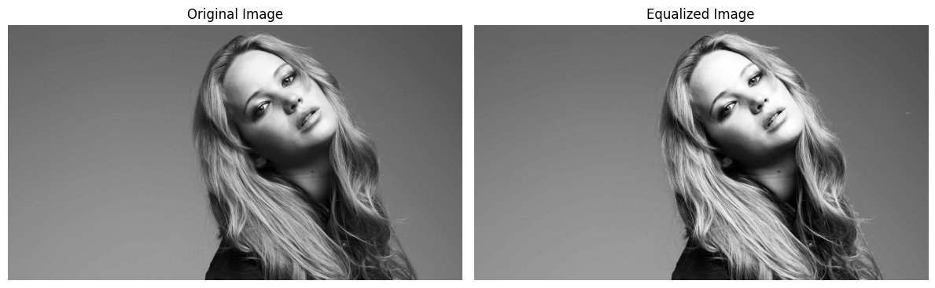

When we compare the original image and the foreground histogram equalized image, we can see the colors in the foreground in the equalized image have reduced. It means that the original image colors are more biased towards the light intensities.

But when we go to the grayscale, we can see that the image brightness seems to be increased and the image has pleasantly enhanced.

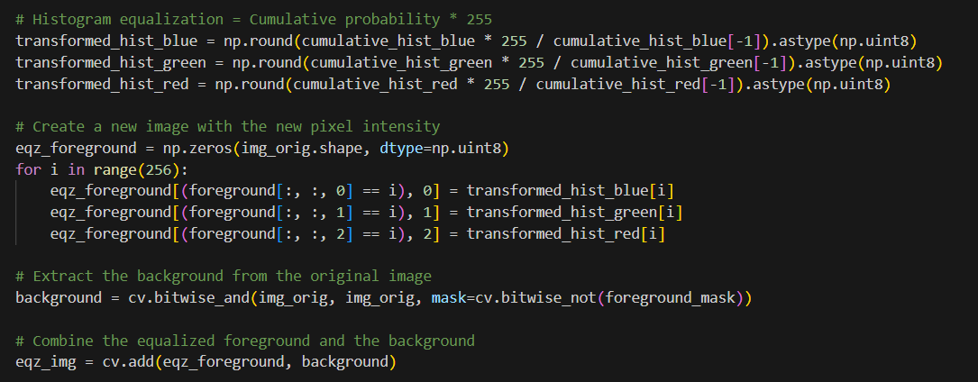

**Question 7**

1. Filter with Sobel operator by using the existing **filter2D** function.

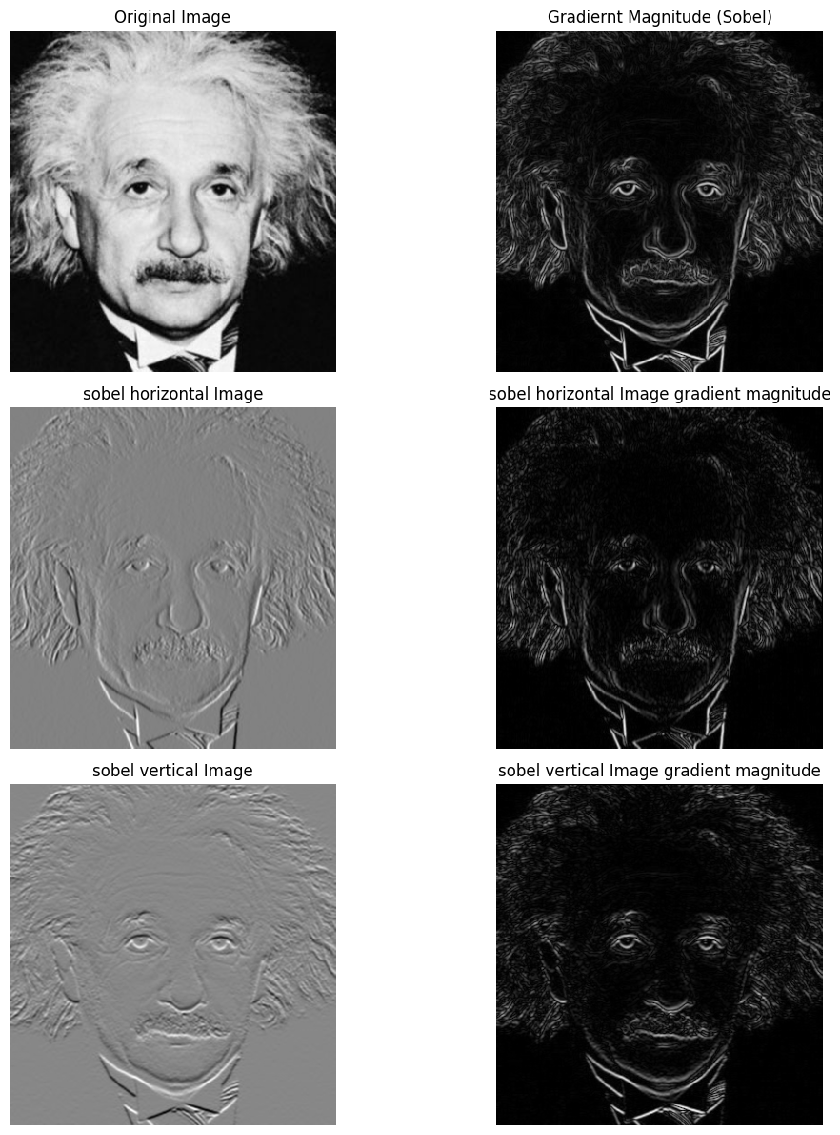

Here I have filtered the image by using the Sobel horizontal and Sobel vertical operators and plotted the gradient magnitude for each Sobel horizontal and vertical filter output. Also, I have plotted the resultant gradient magnitude by using both Sobel vertical and horizontal outputs.

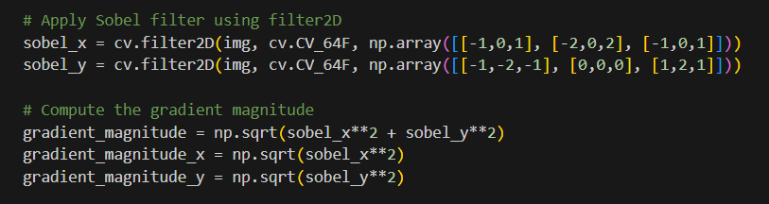

1. The code that I wrote to do Sobel filtering is an **iterative function** and the function outputs are as follows.

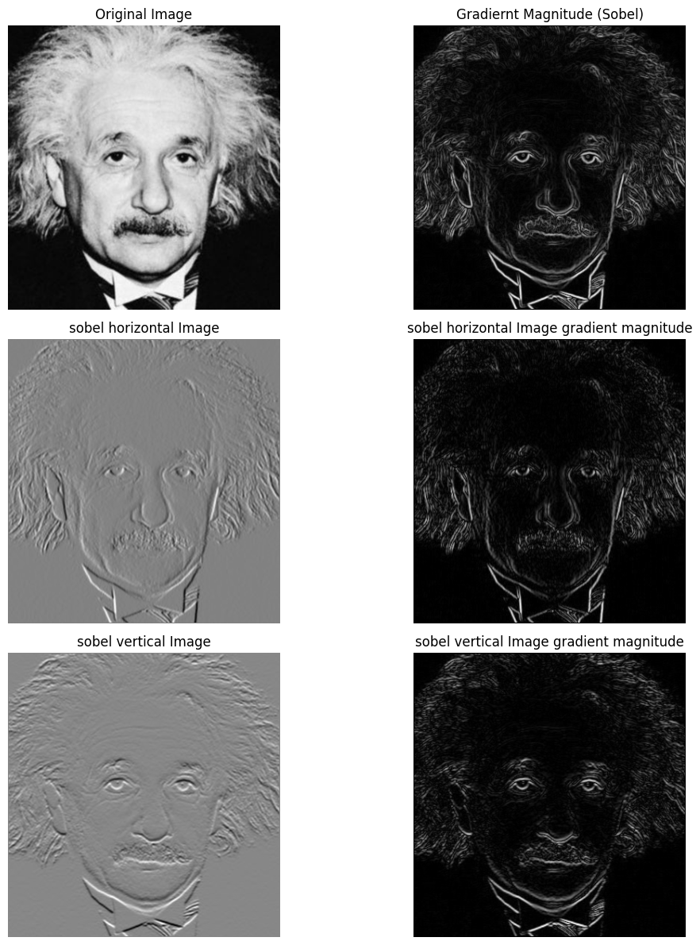

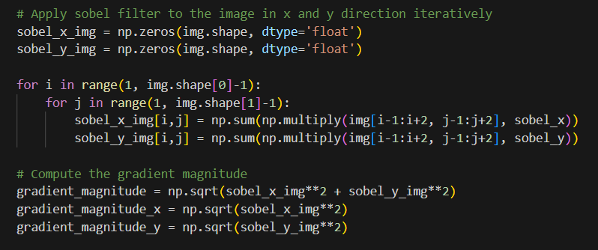

1. Then the obtained results by using matrix multiplication property are as follows,

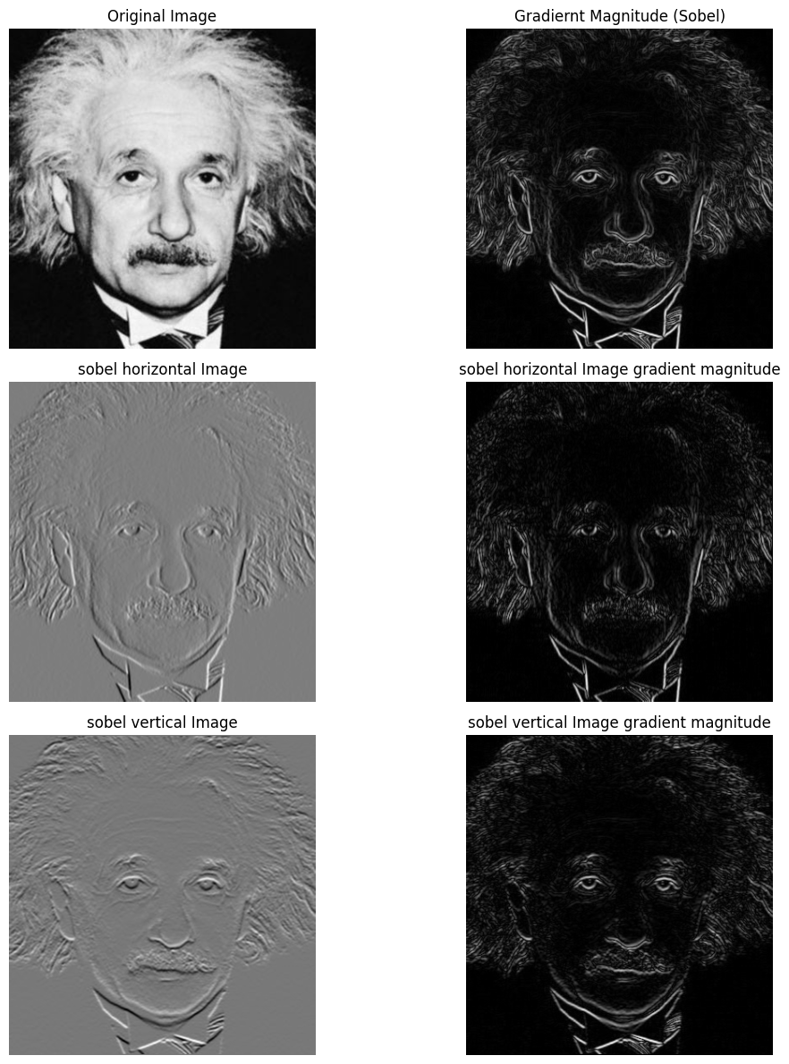

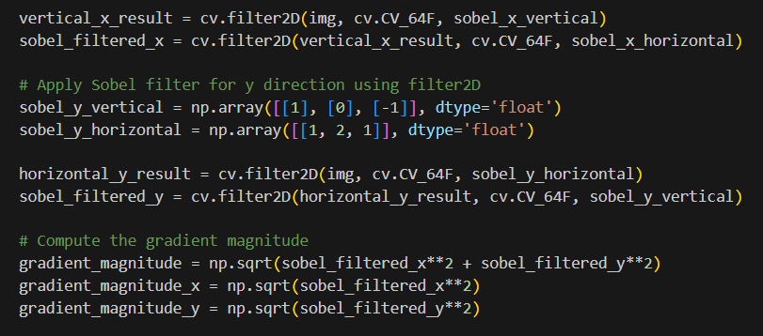

**Question 8**

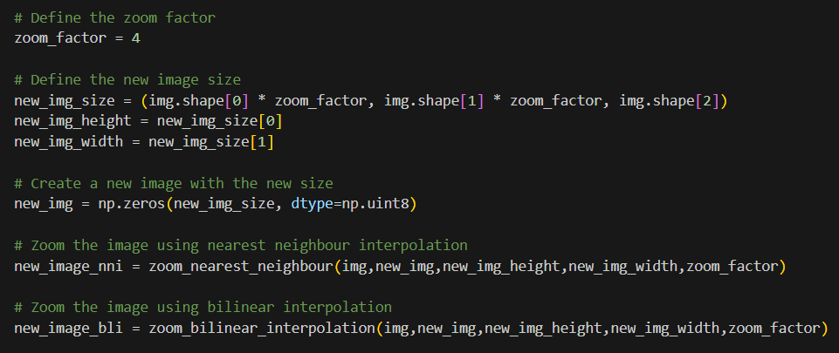

Nearest-neighbor interpolation

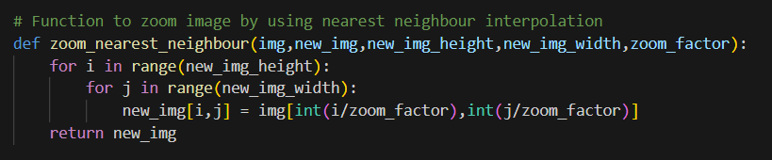

SSD for im01 = 39.240651041666666

SSD for im02 = 16.20416898148148

SSD for im04 = 81.65426066583076

Bilinear interpolation

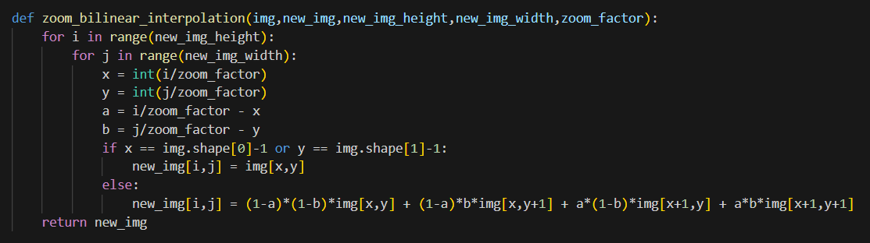

SSD for im01 = 39.240651041666666

SSD for im02 = 16.20416898148148

SSD for im04 = 81.65426066583076

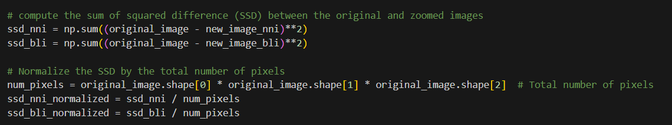

**Question 9**

1. Original image, final segmentation mask, foreground image, background image.

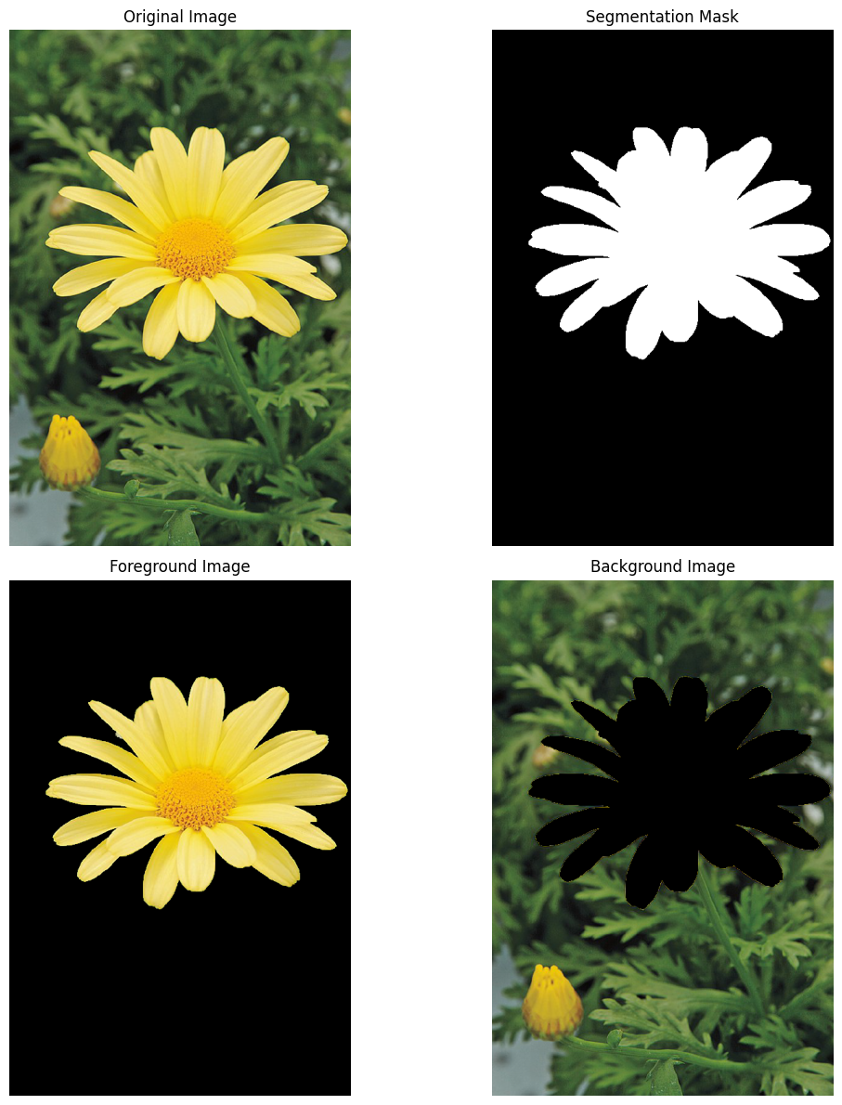

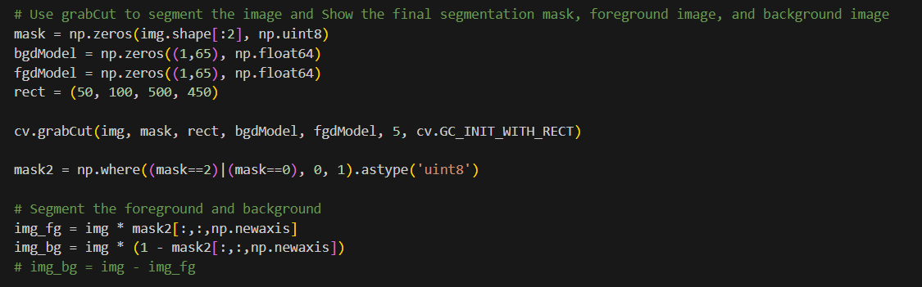

1. To blur the background, I added a Gaussian noise. The original background and blurred background are,

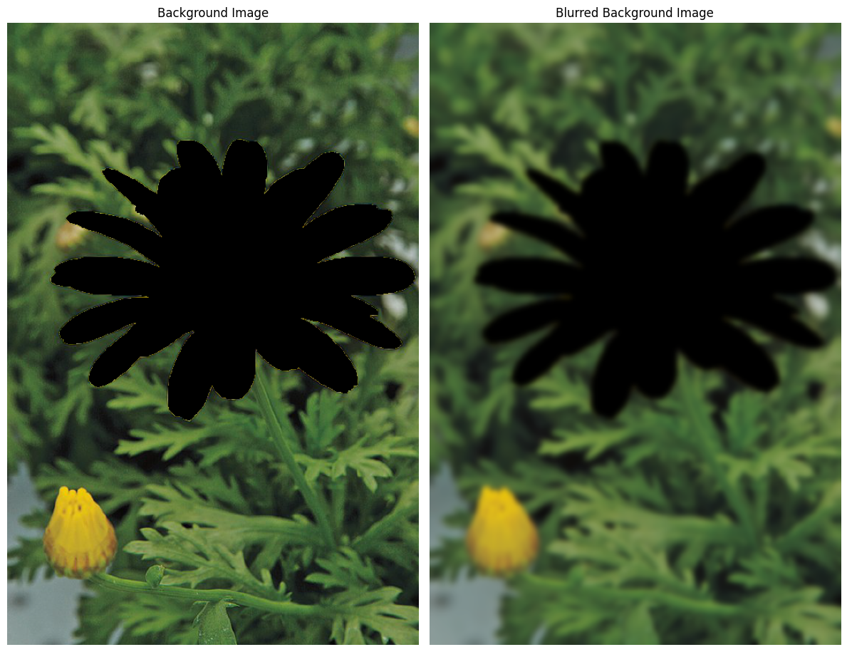

After that, I added the blurred background to the foreground. The original image and the enhanced image are as follows,

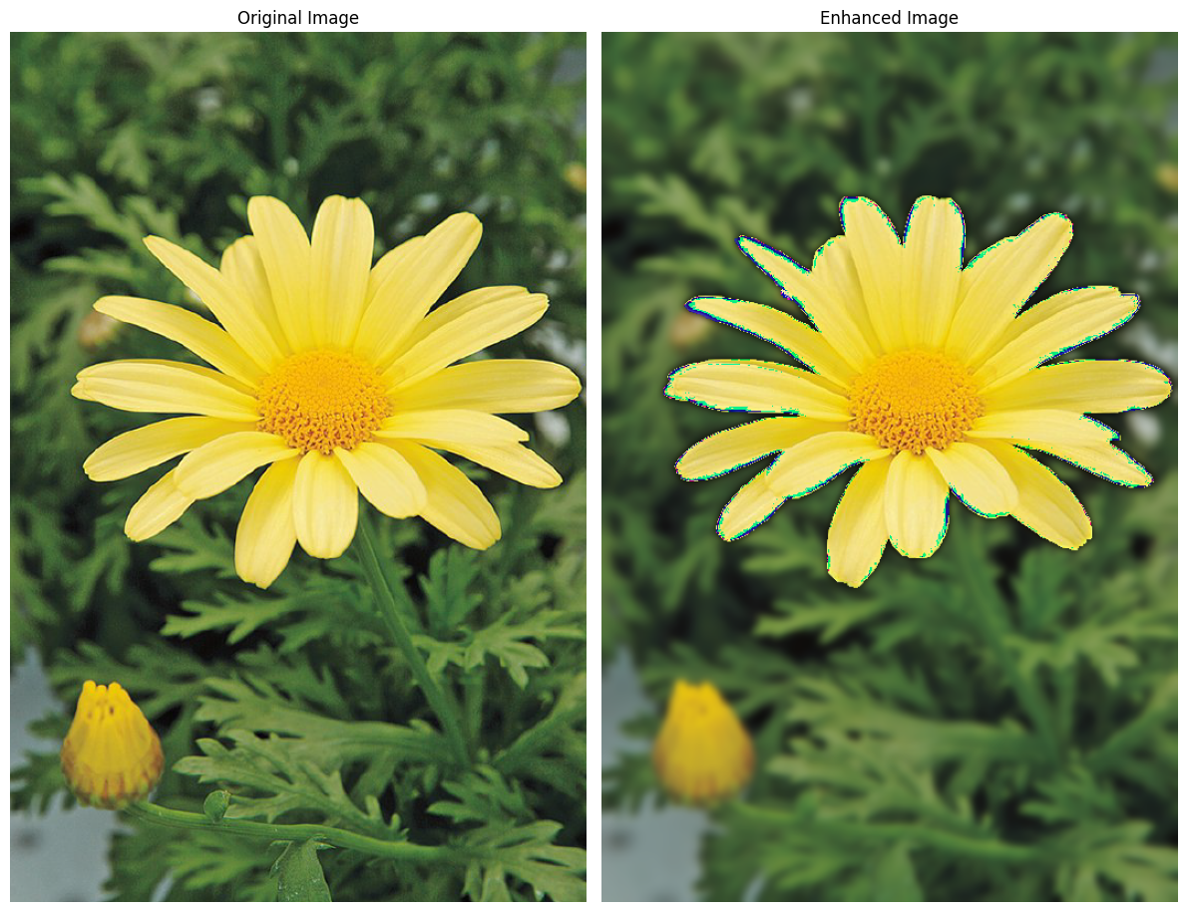

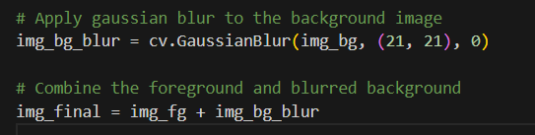

1. To Segment the image to the foreground and background I used the GrabCut algorithm. It is a popular algorithm for image segmentation. It works by estimating the pixels that belong to the foreground and background based on an initial rectangle. However, the algorithm may not be perfect, especially around the edges of the object.

And I use the Gaussian filter to blur the background. Gaussian blur is a smoothing filter that averages the values of neighboring pixels. When applied to the background of an image, it will blur both the true background and the pixels that were incorrectly classified as background. This is because the blur does not distinguish between the two types of pixels.

Because of these reasons, there is quite dark in the enhanced image background just beyond the edge of the flower.